Samara Vargas Linares

Final Project: Completed Documentation
Completed Documentation

Table of Contents
Original Planning Document 2
Network Diagram 4
ADDS Diagram 5
ADDS Server 6
Organizational Units (Ous) 8
DHCP Server 10
Client Machine 13
File Server 16
Shared Folders 17

Original Planning Document
Project Theme: Wizarding World (Harry Potter)
Domain Name: WizardingWord26.net
Domain Password: Alohomora01
Operating System: Windows Server Datacenter
SERVER CONFIGURATION
Server #1: DurmstrangS26SVL
Roles: Active Directory Domain Services (ADDS), DNS
IP Address: 192.168.8.2
Subnet Mask: 255.255.255.0
DNS: 192.168.8.2
Server #2: BeauxbatonsS26SVL
Roles: ADDS, DHCP
IP Address: 192.168.8.3
Subnet Mask: 255.255.255.0
DNS: 192.168.8.2
Server #3: (FSRM Server)
Roles: File Server Resource Manager (FSRM)
IP Address: 192.168.8.4
Subnet Mask: 255.255.255.0
DNS: 192.168.8.2
ORGANIZATIONAL UNITS AND USERS
OU: Gryffindor26S
Group: G_Gryffindor26S
Users: Harry Potter (hpotter26s), Hermione Granger (hgranger26s), Ron Weasley (rweasley26s)
OU: Ravenclaw26S
Group: G_Ravenclaw26S
Users: Luna Lovegood (llovegood26s), Filius Flitwick (fflitwick26s), Helena Ravenclaw (hravenclaw26s)
OU: Slytherin26S
Group: G_Slytherin26S
Users: Draco Malfoy (dmalfoy26s), Tom Riddle (triddle26s), Regulus Black (rblack26s)
CLIENT AND NETWORK CONFIGURATION
Client Name: Gringotts26S
Operating System: Windows 10 or 11
IP Assignment: DHCP
DHCP Scope Name: HogsmeadeScope26S
IP Range: 192.168.8.100 – 192.168.8.140
NETWORK SHARES
Shares: Gryffindor, Slytherin, Ravenclaw

Network Diagram
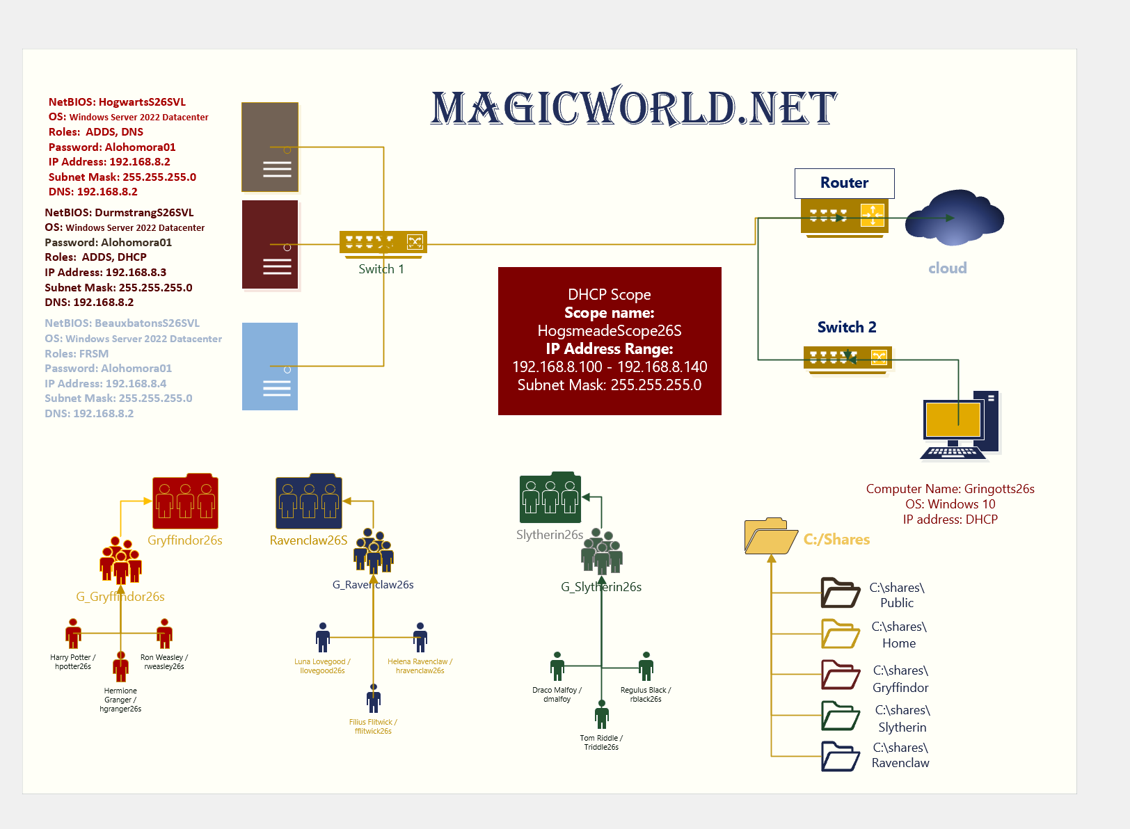
Figure 1 Network Diagram
(The requirements are Virtual Machine Timestamp, this is not a virtual machine but a photo fo the visio NetworkDiagram, So, it doesn’t have a timestamp)

ADDS Diagram
Figure 2 ADDS Diagram
(The requirements are Virtual Machine Timestamp, this is not a virtual machine but a photo fo the visio NetworkDiagram, So, it doesn’t have a timestamp)

ADDS Server
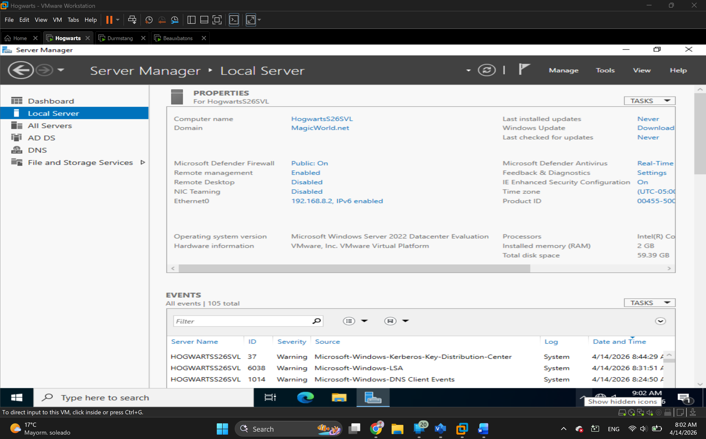
Figure 3 Local Server information showing the server being promoted to a DC

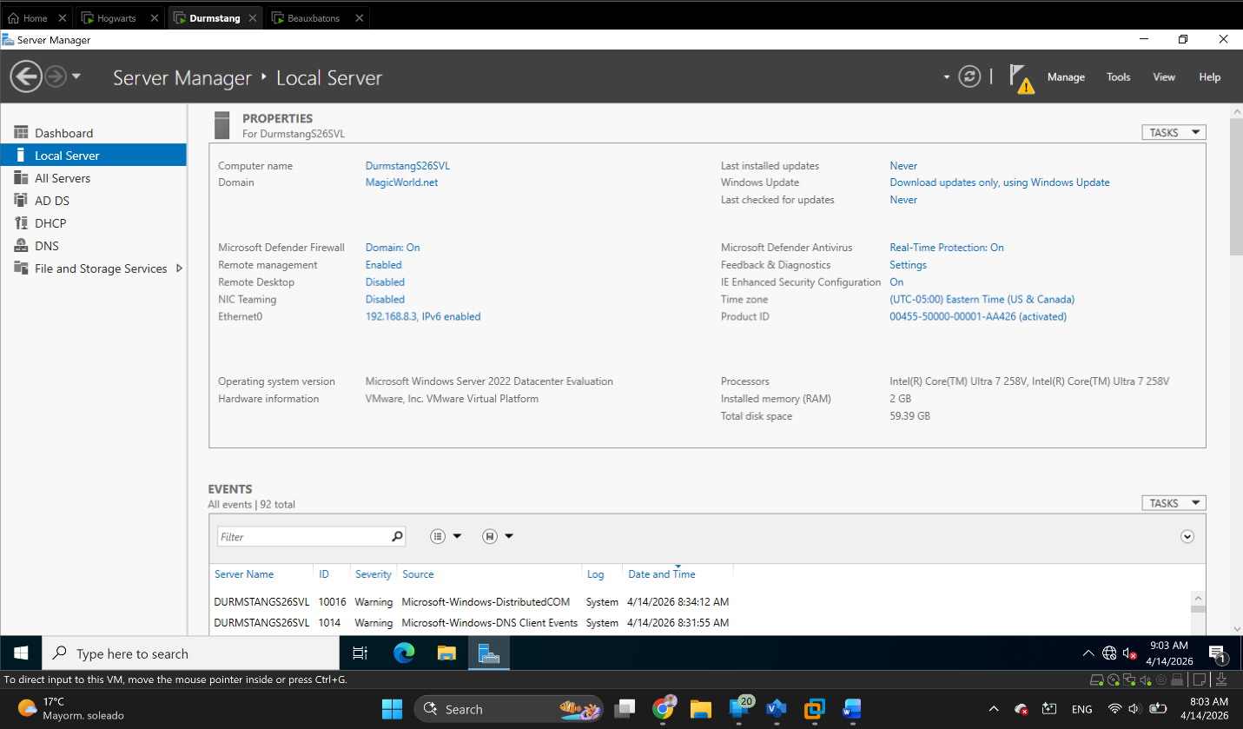
Figure 4 Local Server information showing the server being promoted to a DC

Organizational Units (Ous)

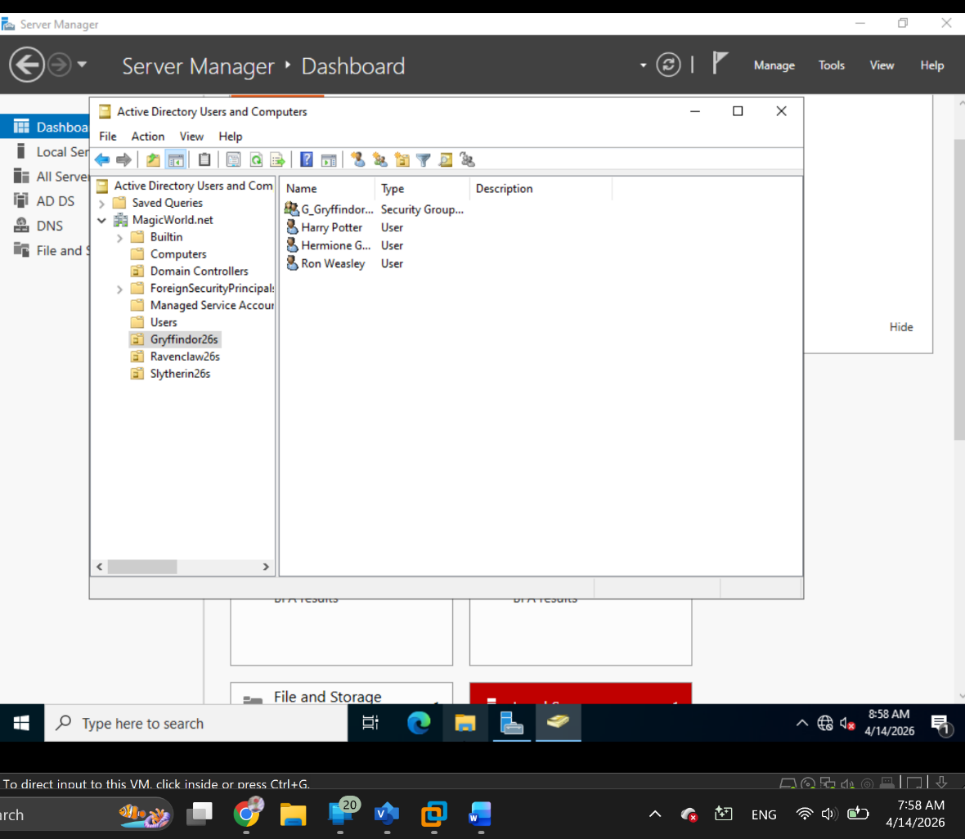
Figure 5 The Gryffindor group and users on their OU

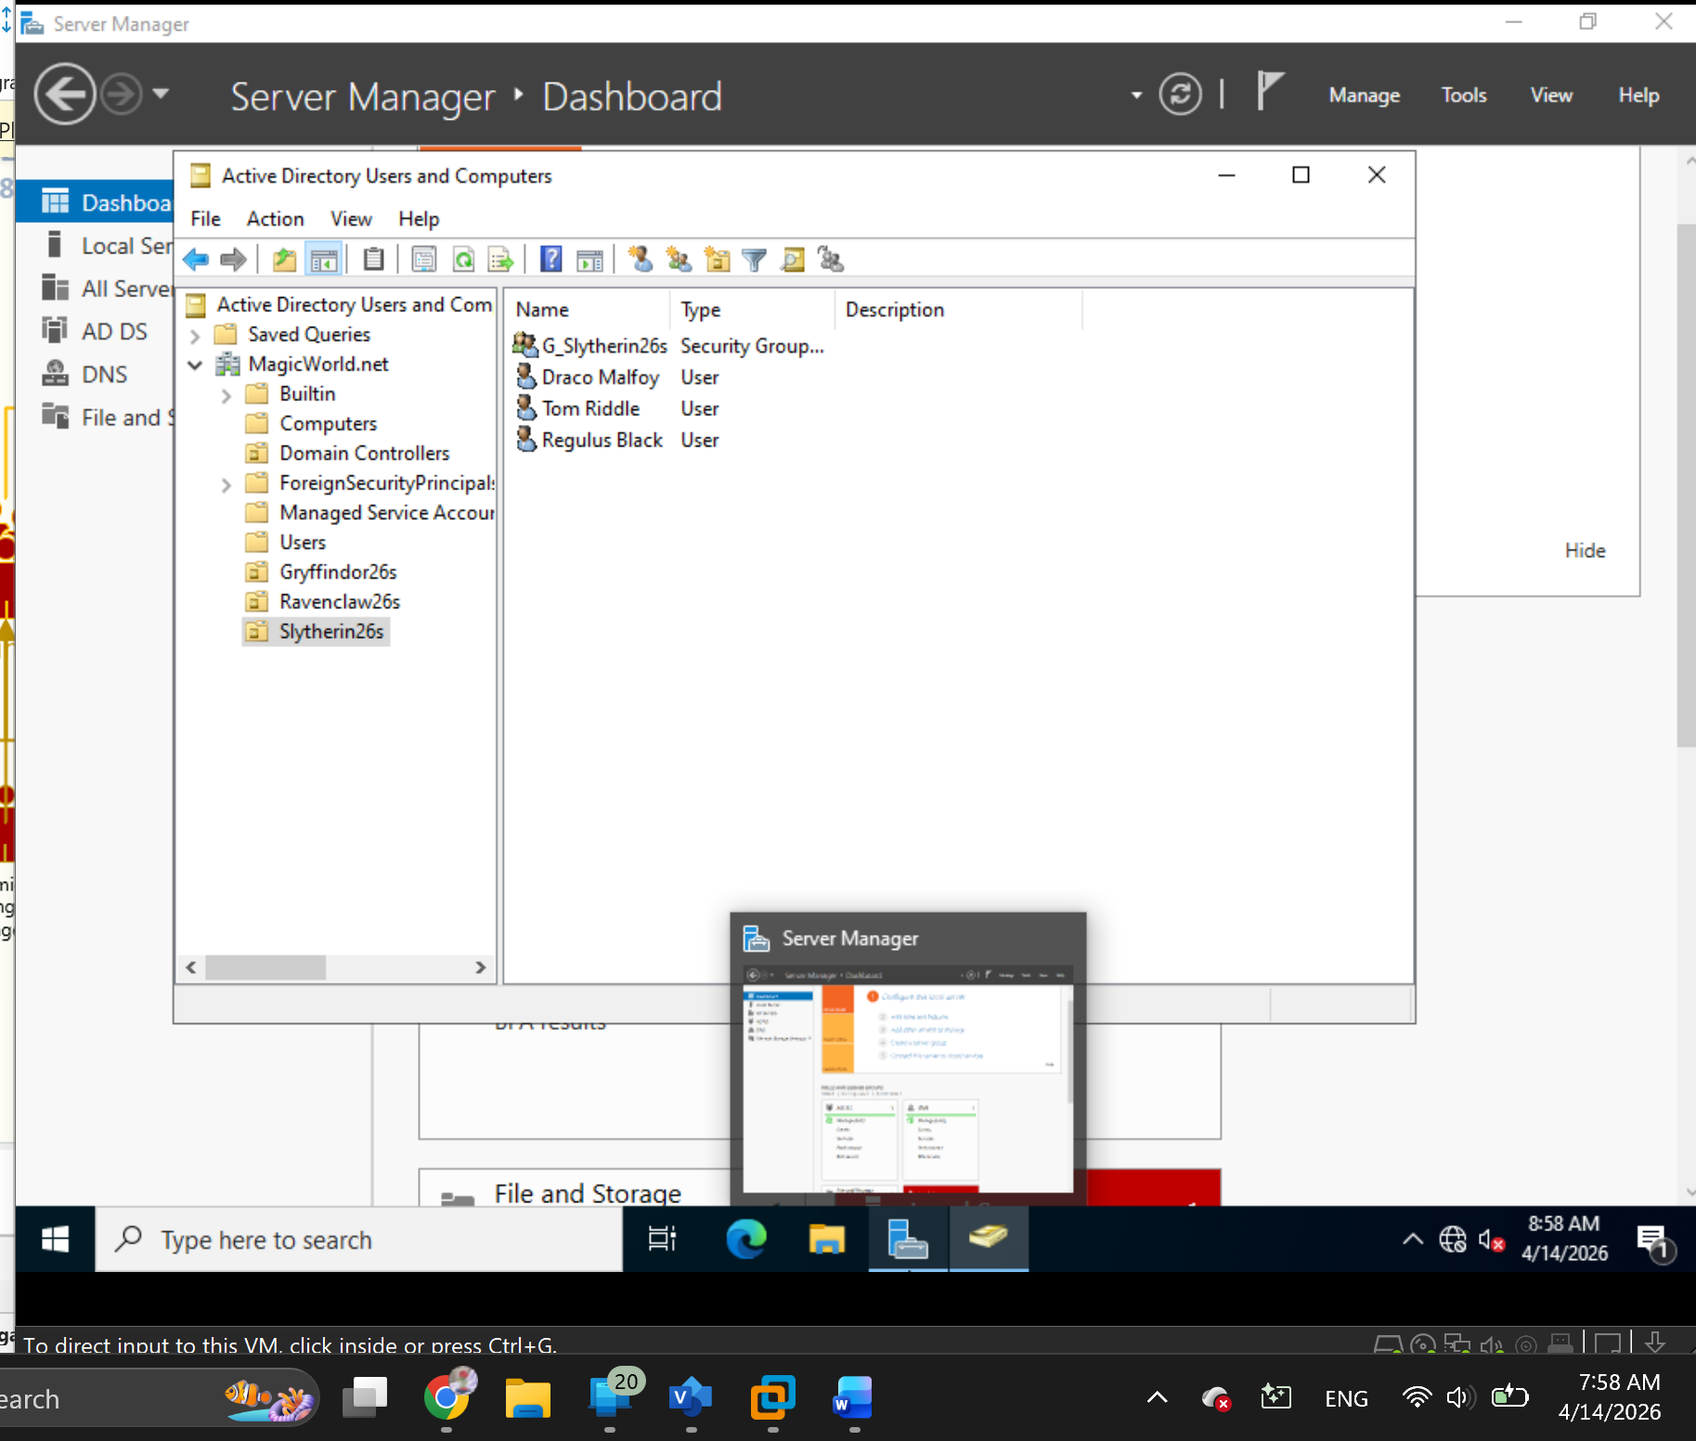
Figure 6 The Slytherin group and users on their OU

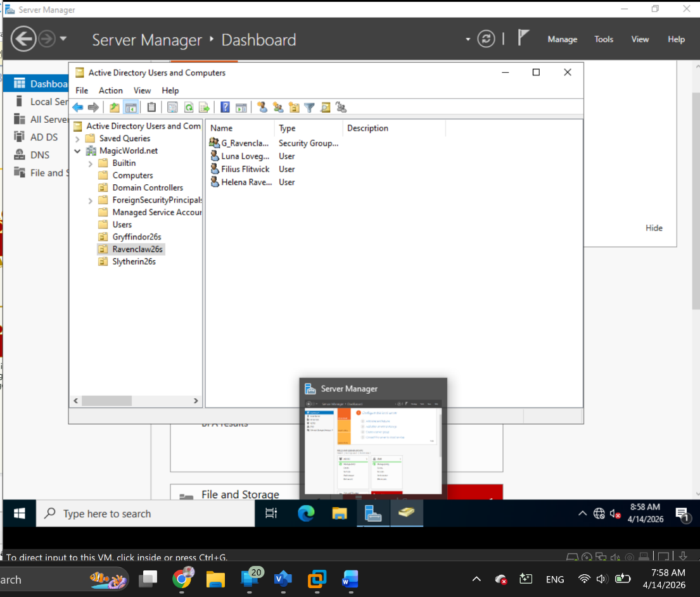
Figure 7 The Ravenclaw group and users on their OU

DHCP Server 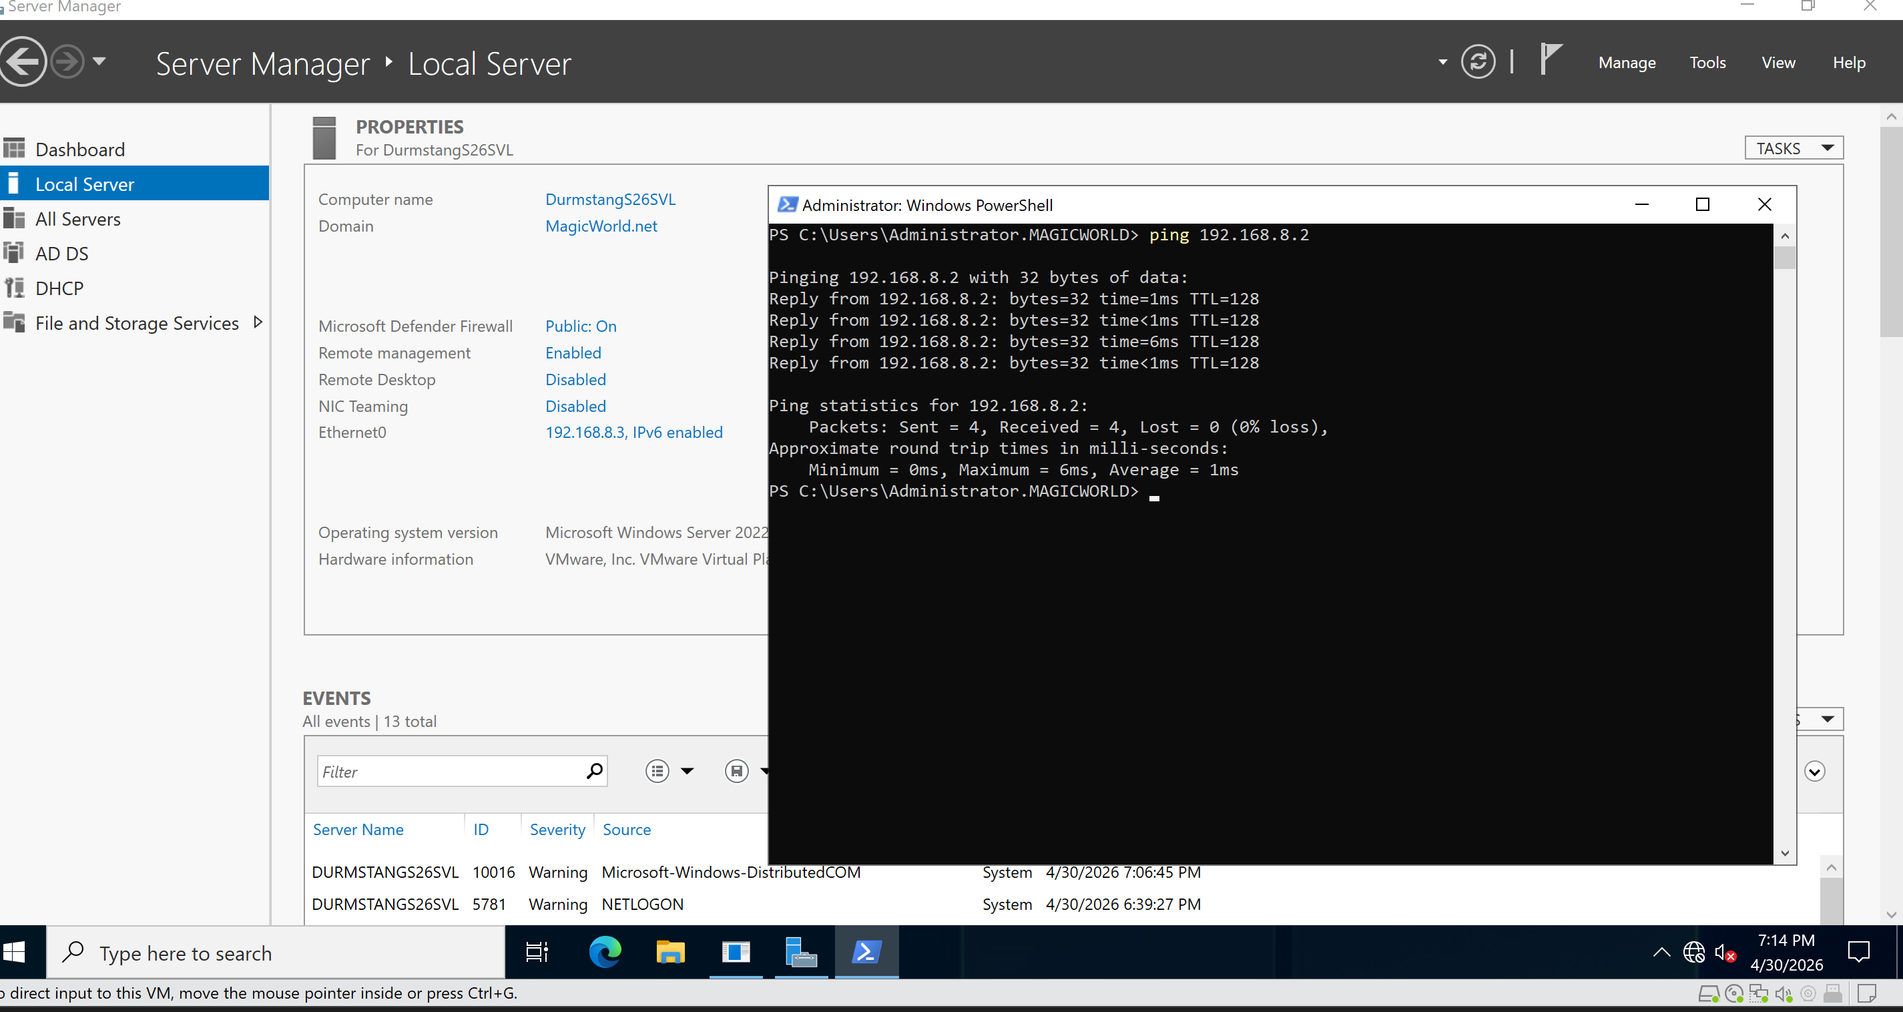
Figure 8 The Local Server screen showing the roles and the Command prompt showing that the server can ping other Server

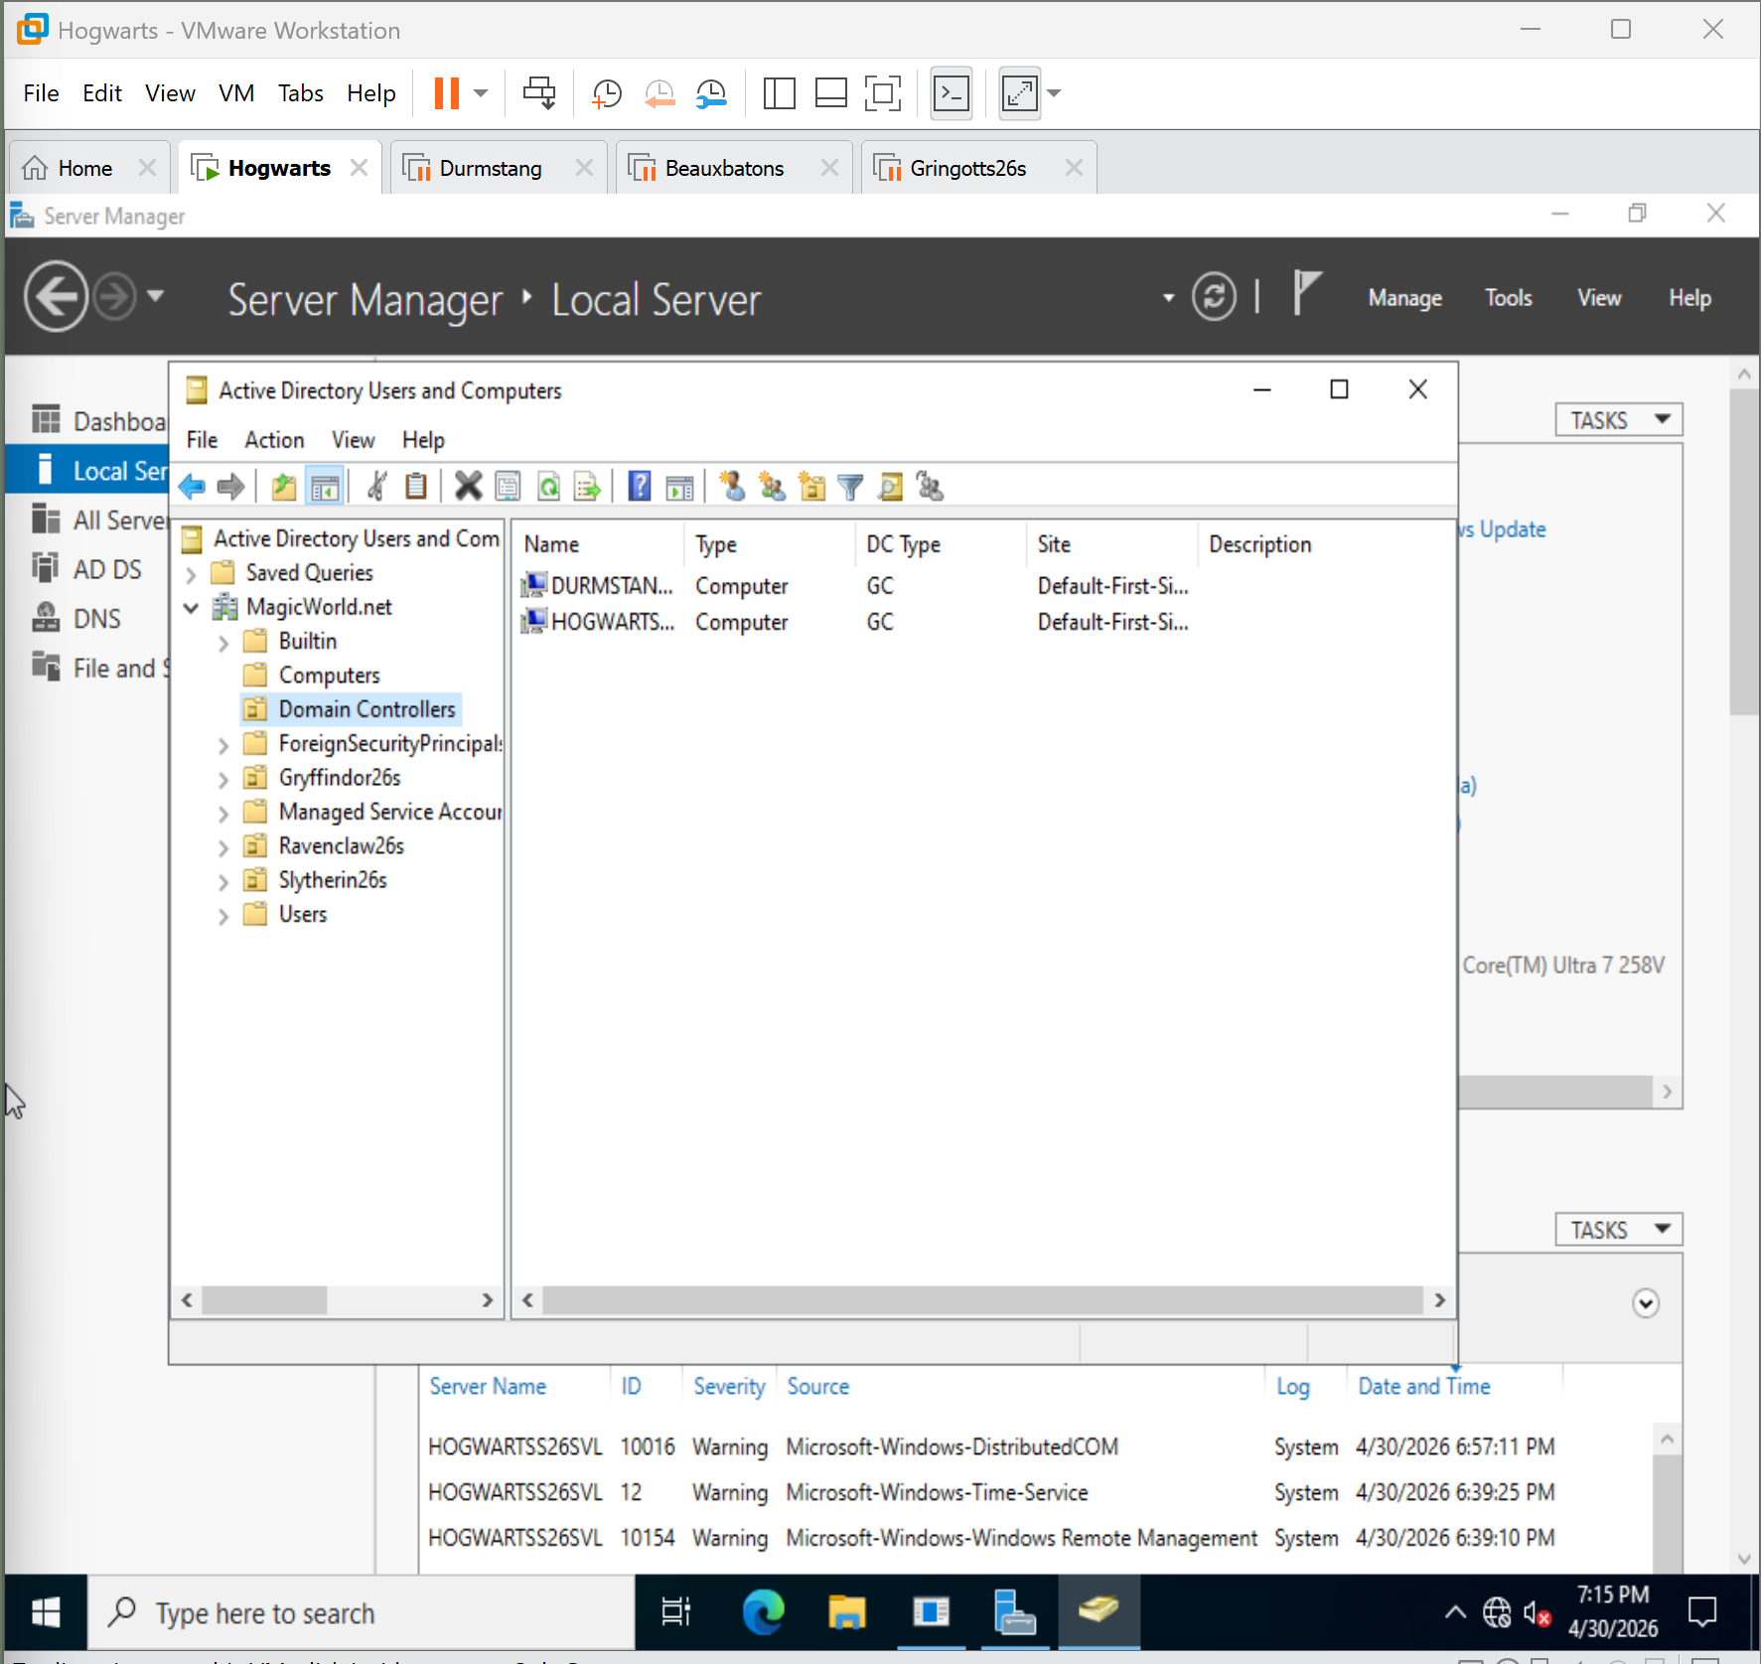
Figure 9 The second server as a DC in the ADUC screen on the primary DC

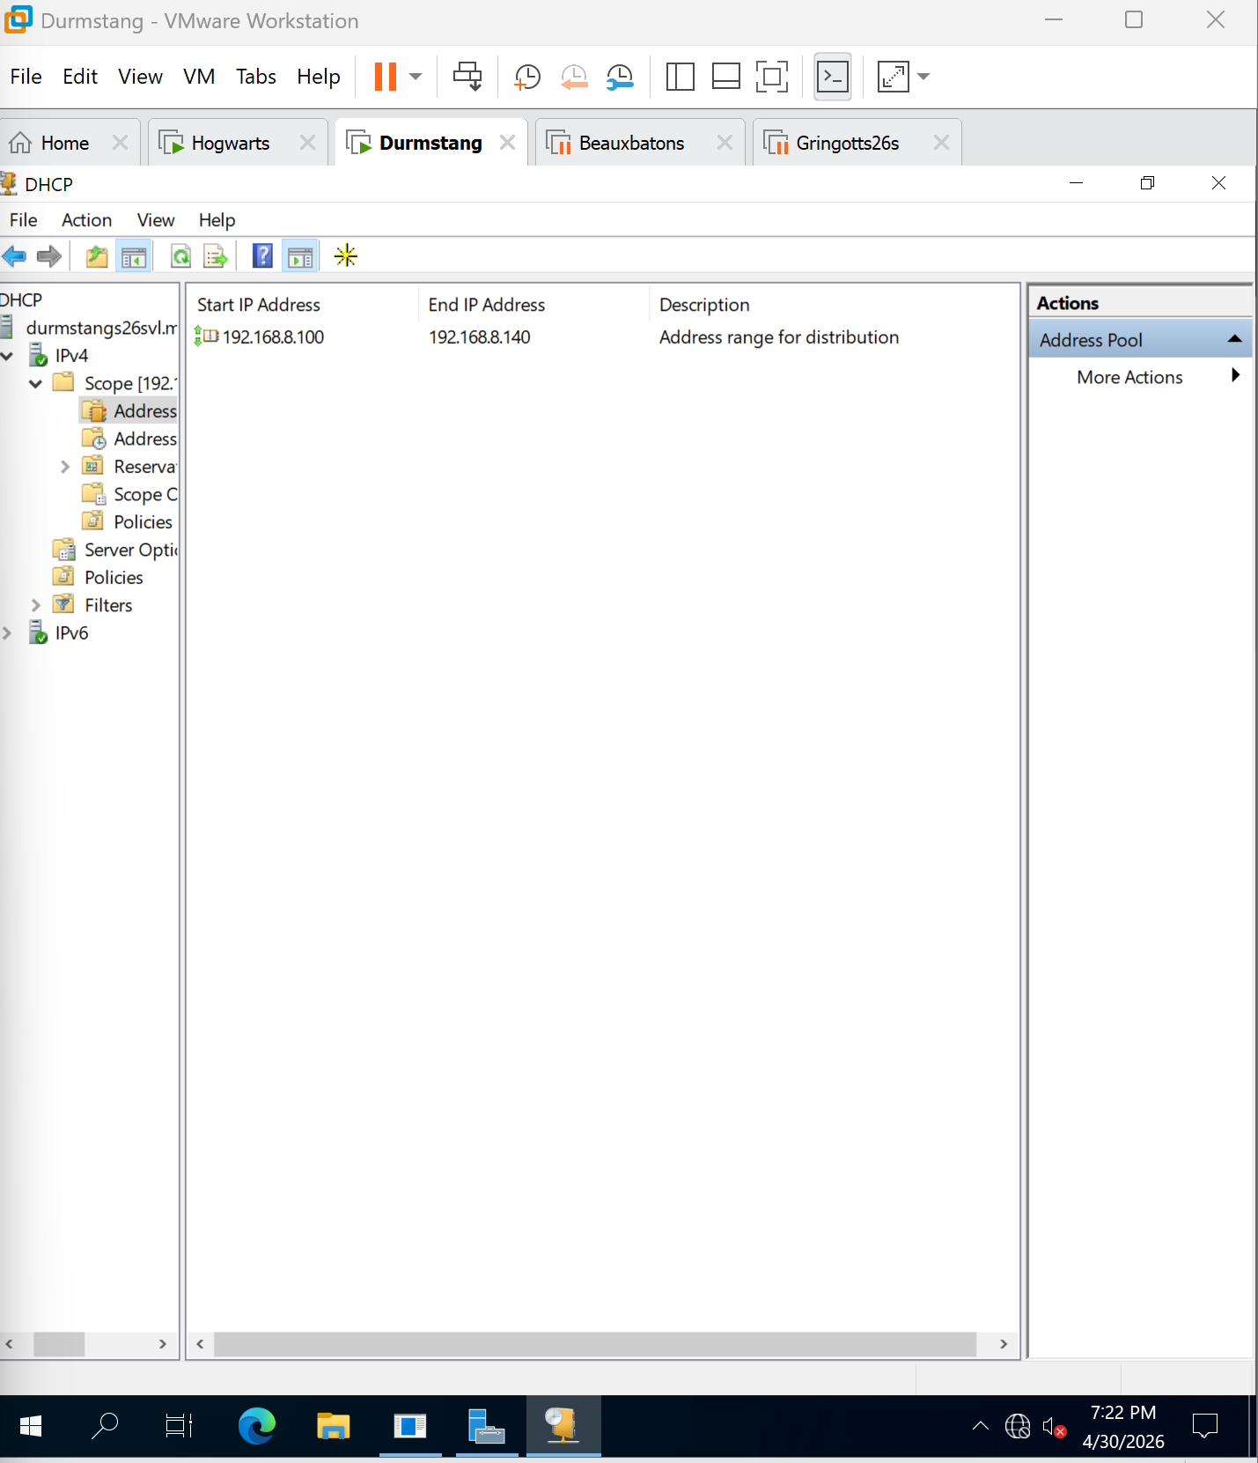
Figure 10 DHCP console showing the scope range

Client Machine 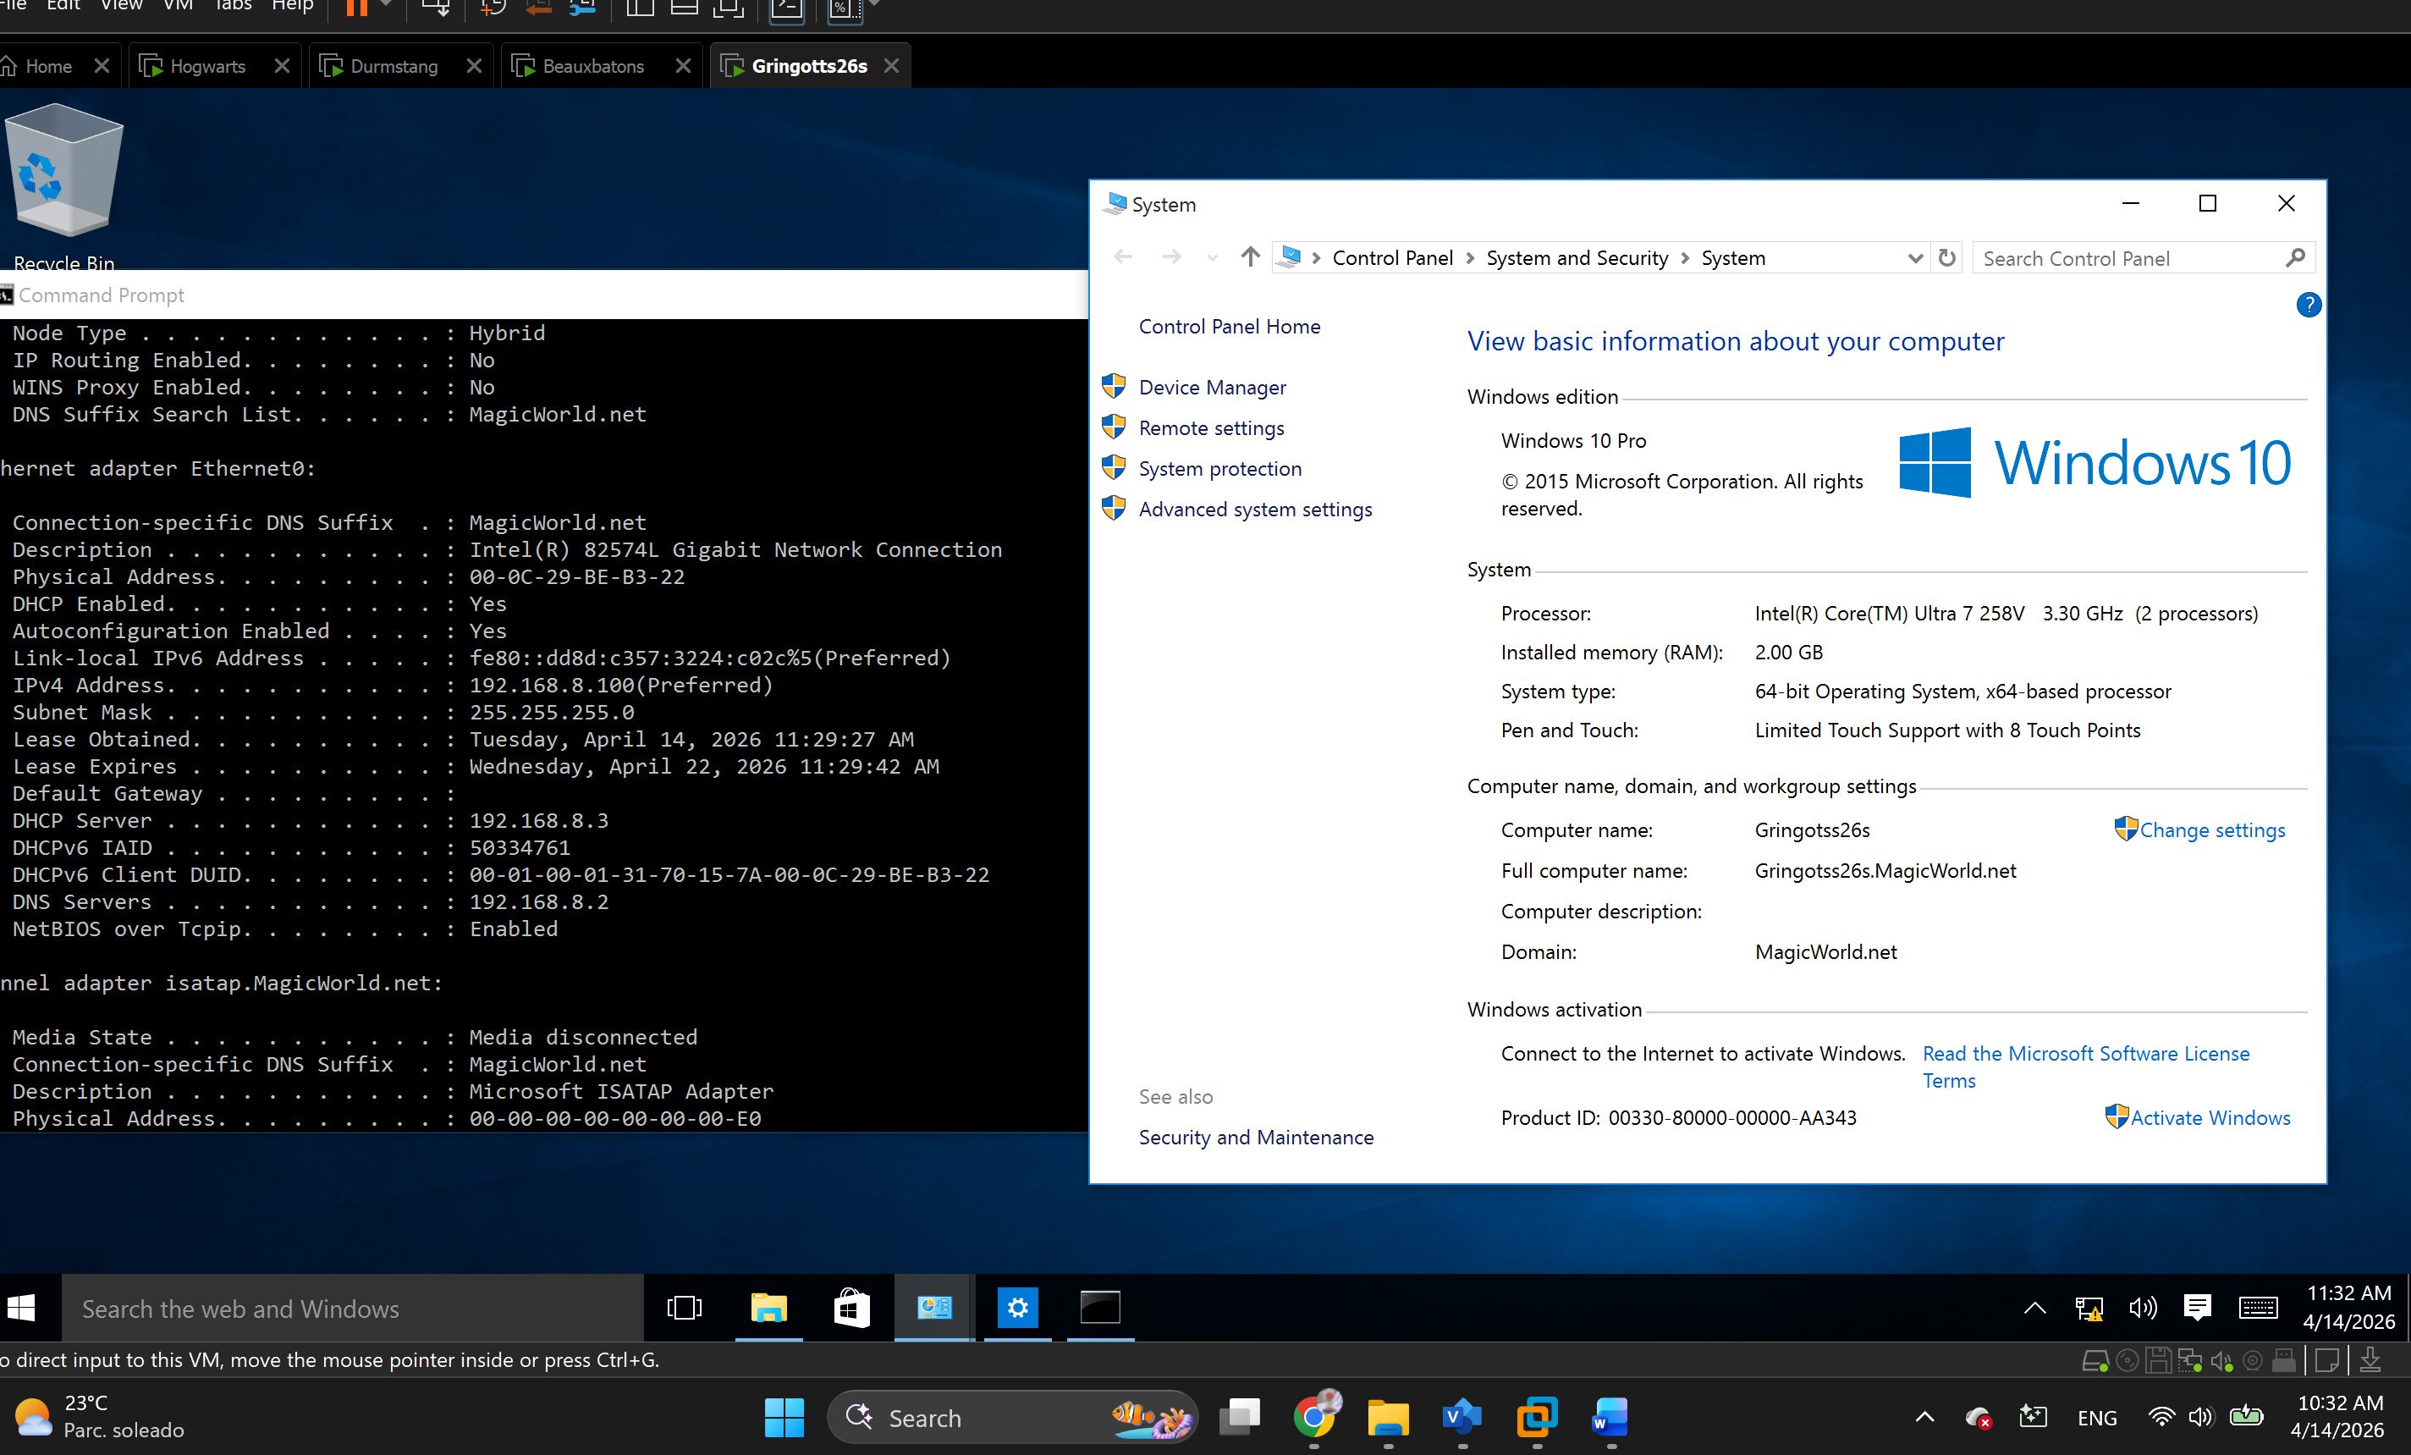
Figure 11 Client Machine Windows 10 is joined to the network

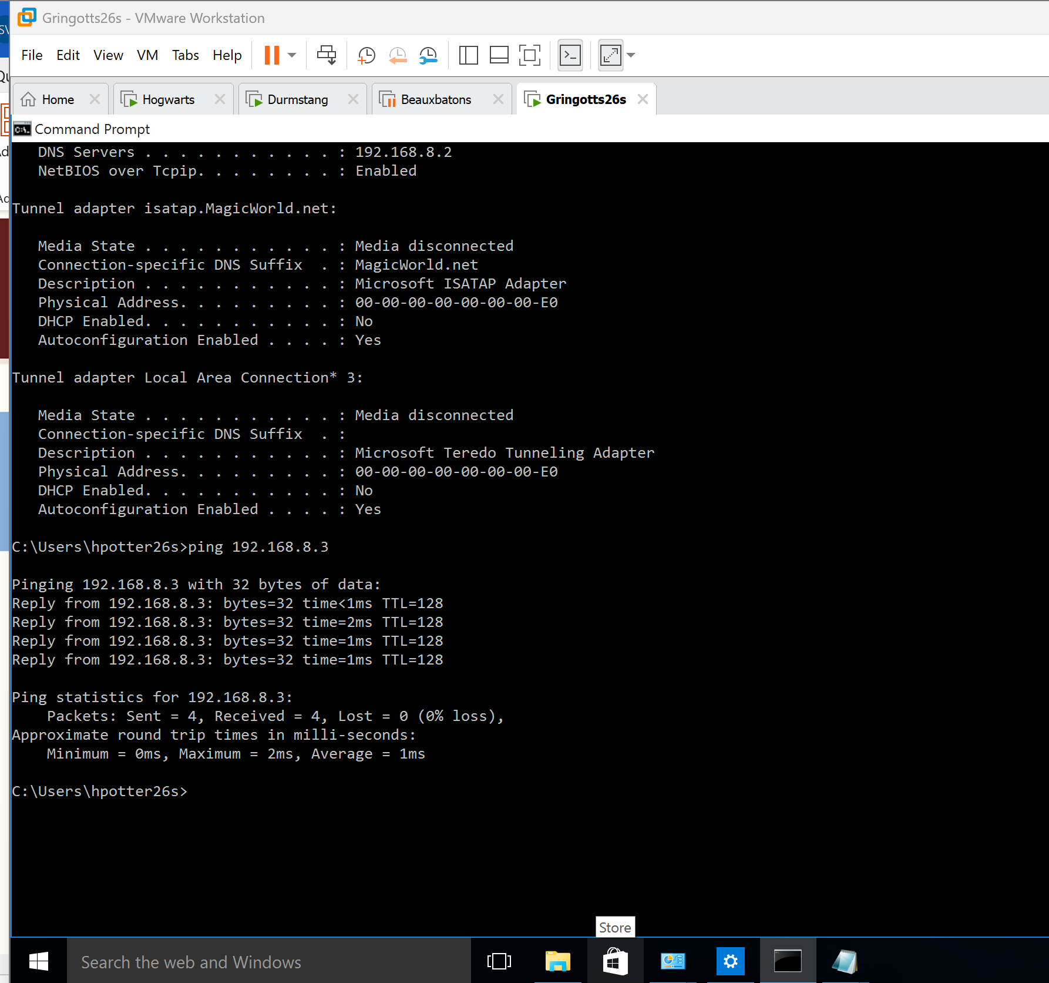
Figure 12 Client Machine being able to Ping a server from the network

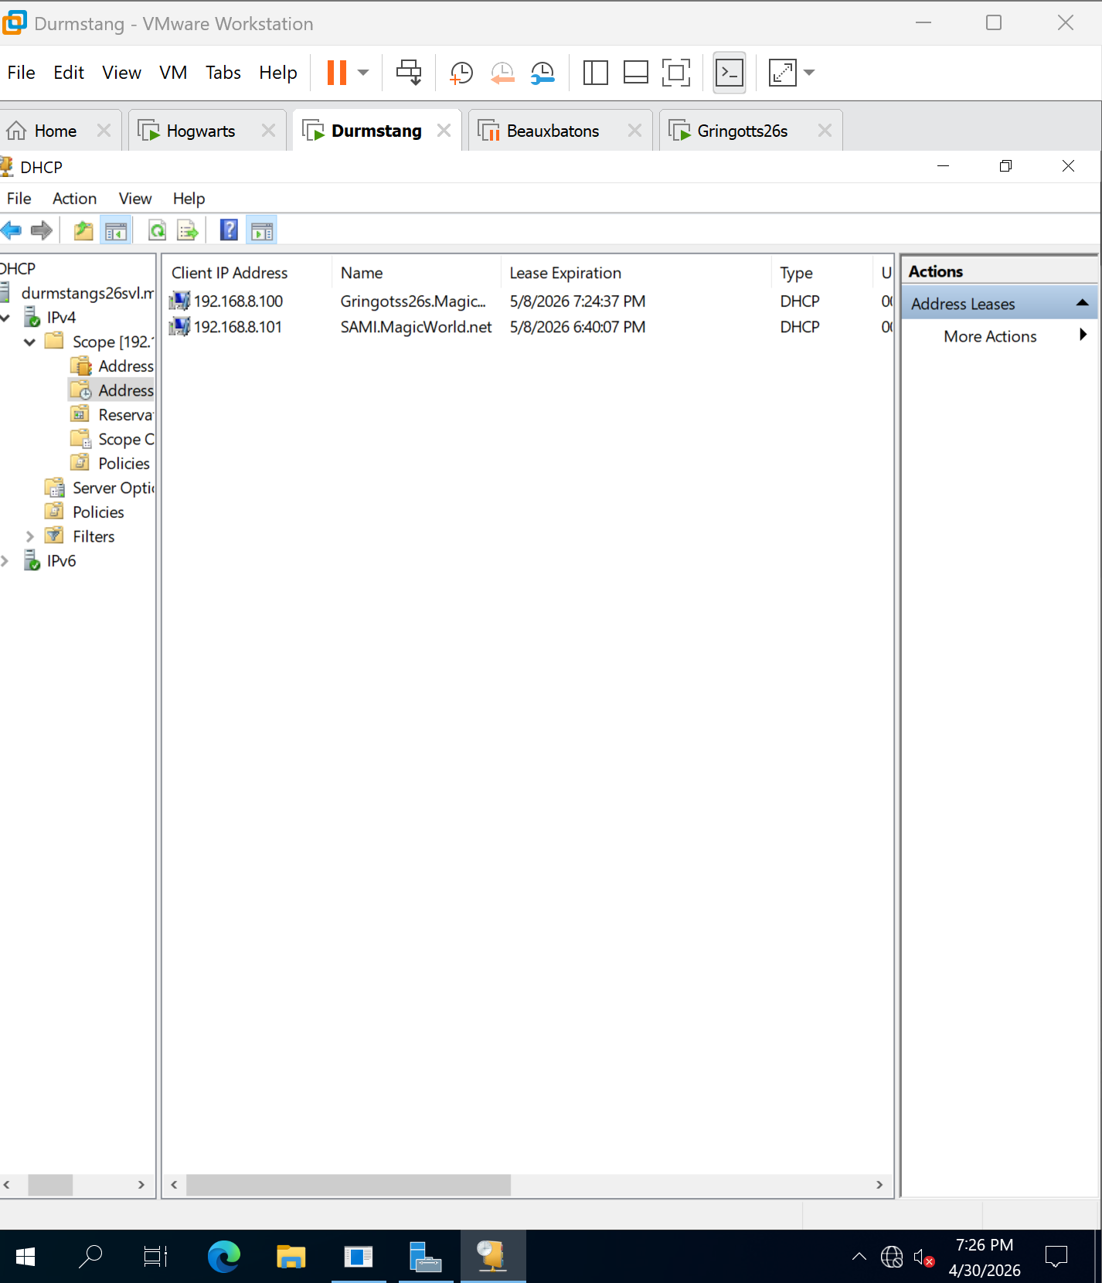
Figure 13 DHCP Console from server 2

File Server
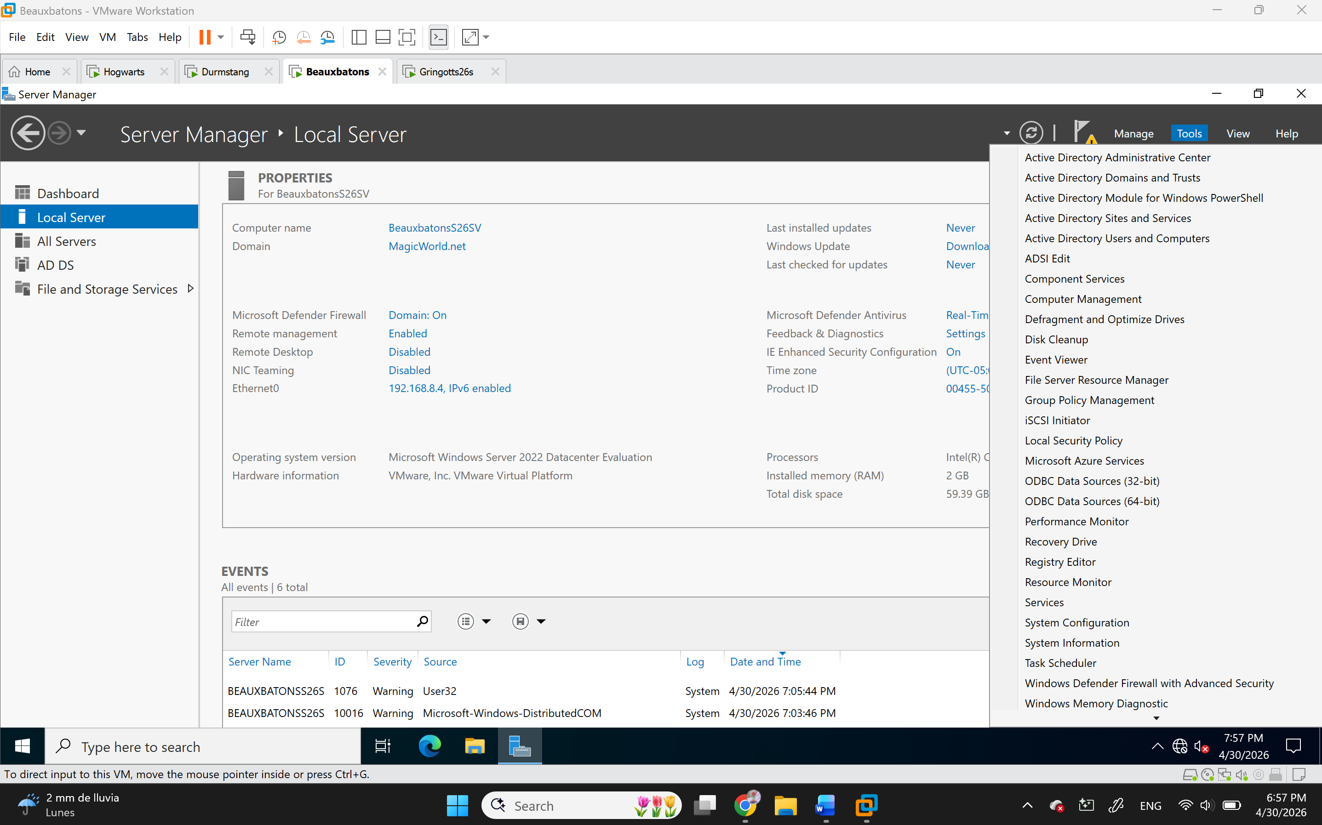
Figure 14 File Server is configured and has FSRM installed

Shared Folders
Figure 15 Local Server on The File Server showing the roles)

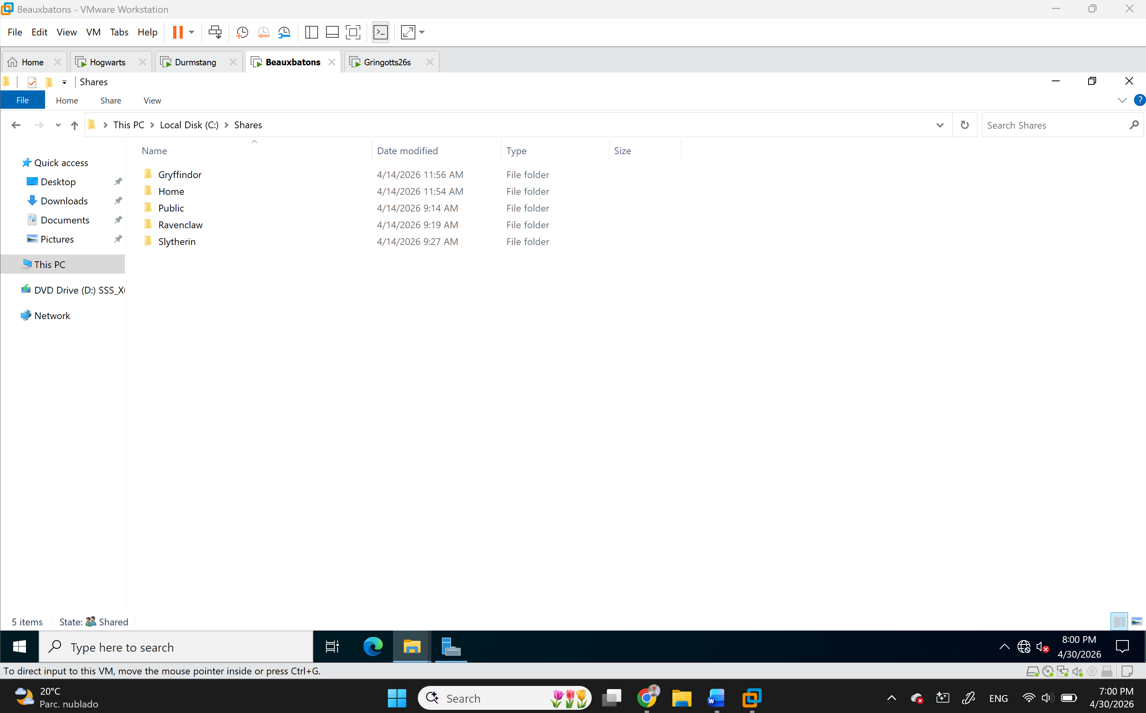
Figure 16 The list of folders on the file server

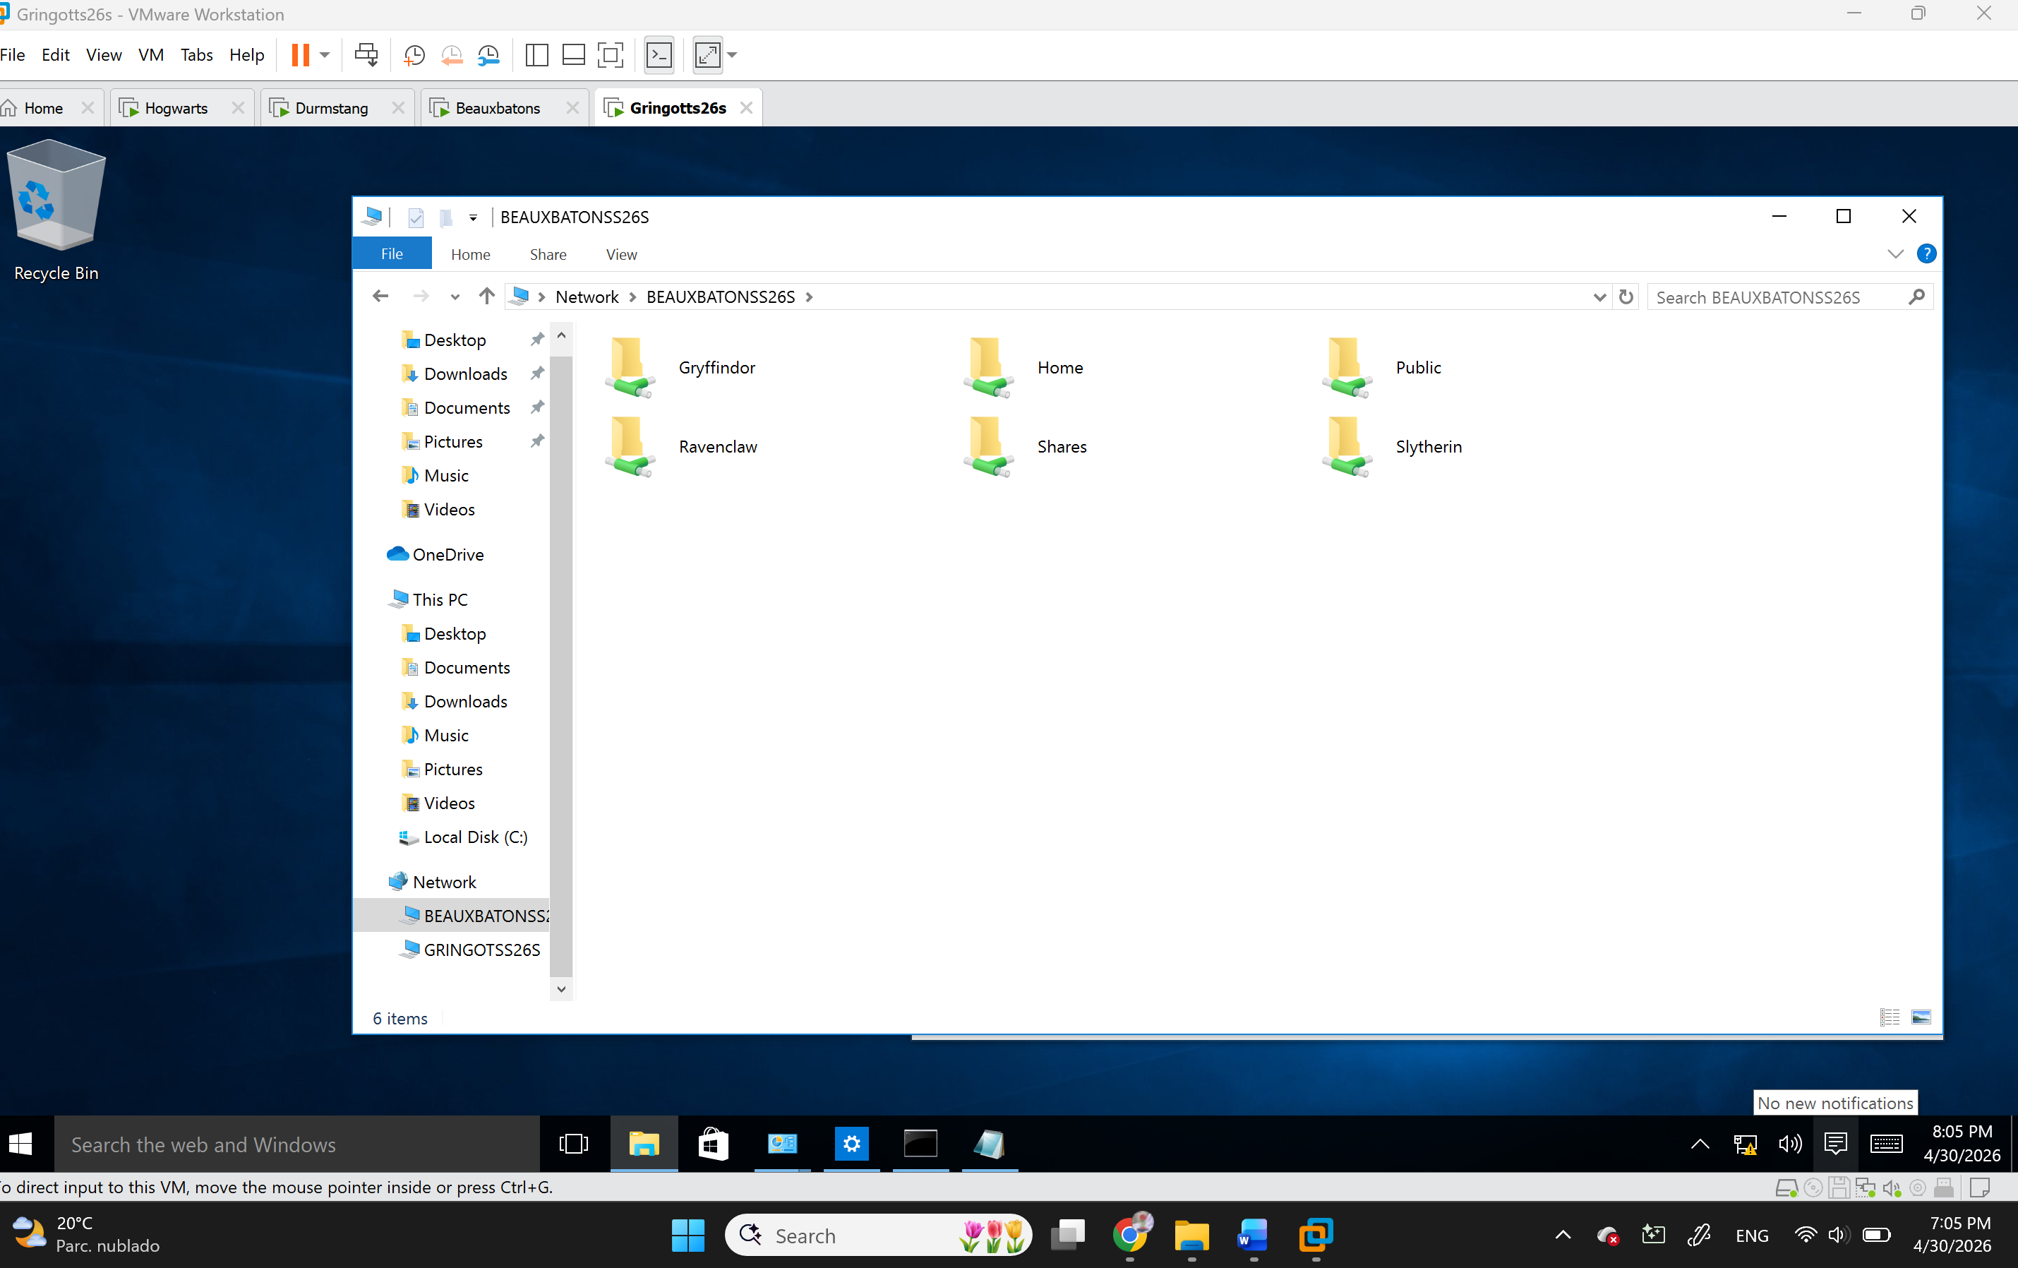
Figure 17 The list of folders on the client machine

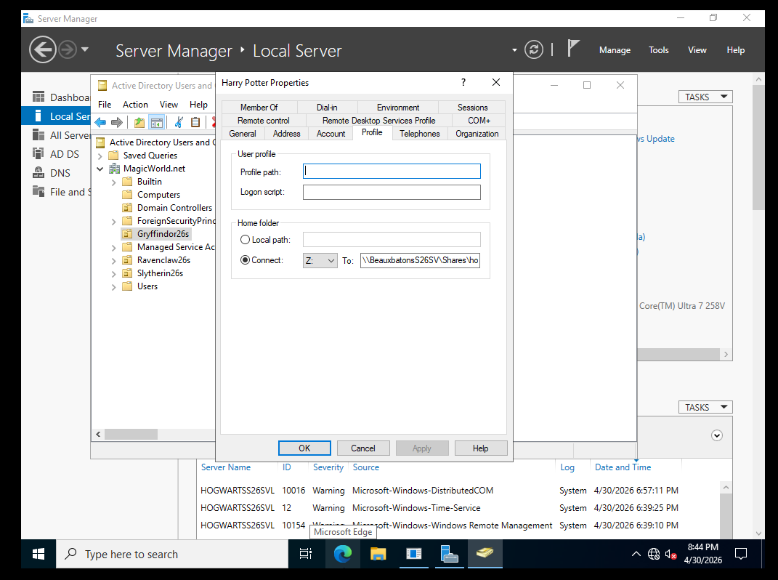
Figure 18 Profile settings showing the drive letter and the path for the shared folde
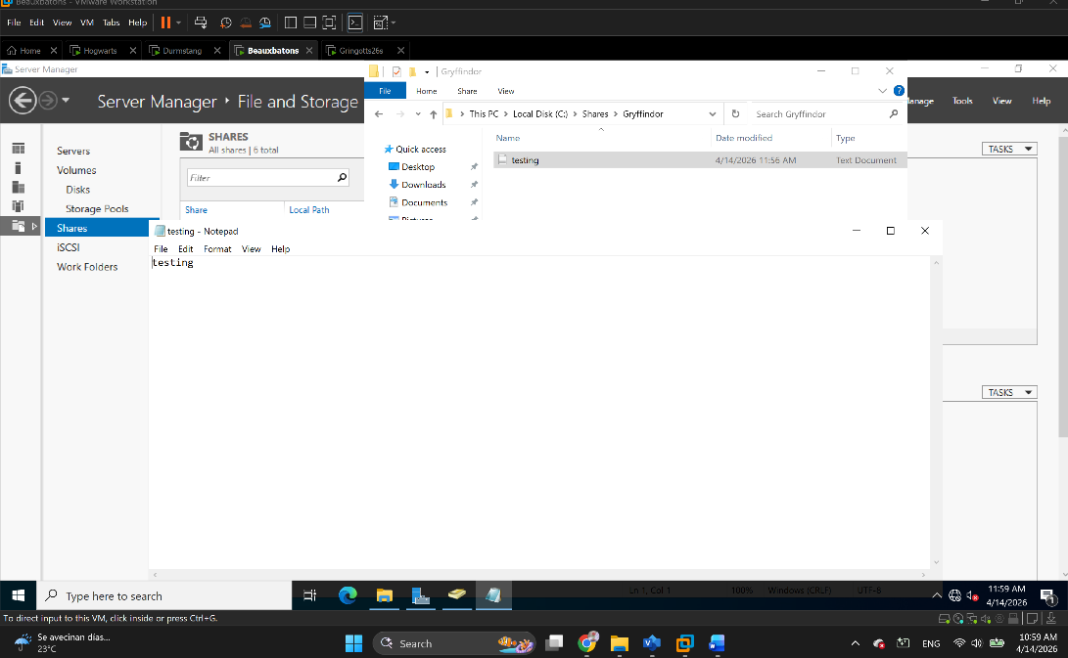
Figure 19 The document created on the client machine, opened up on the file server
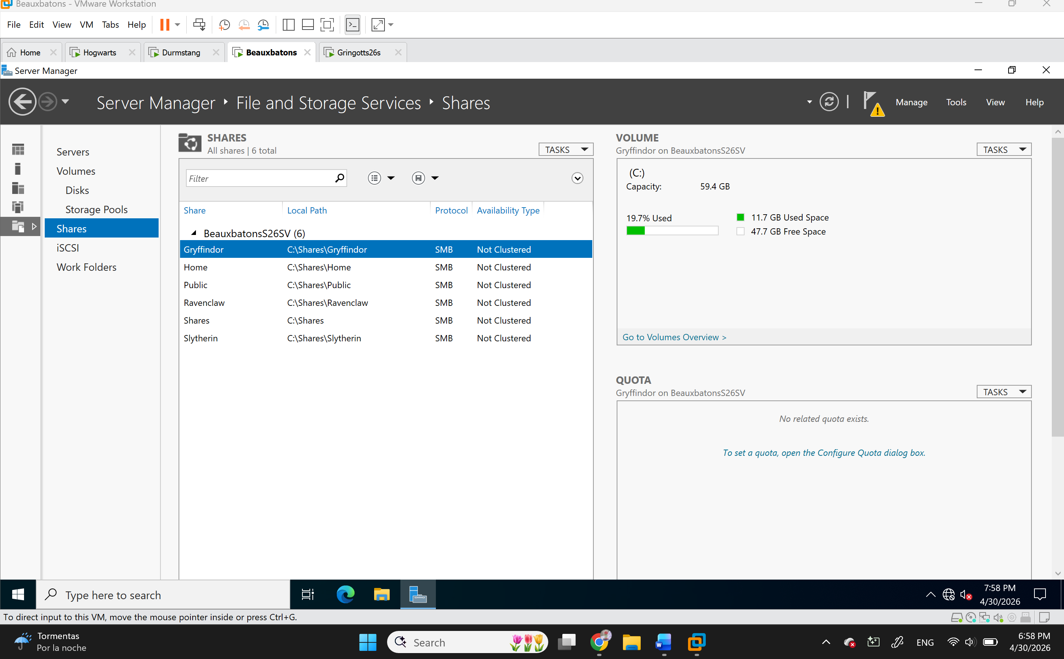
Figure 20 Screenshot from the folder in the Shares area of the File Server

